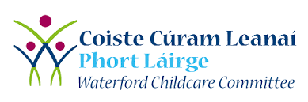


Always Children First Safeguarding Training (2 Day)
VENUE: Viking Hotel, Waterford City
DATE: Tues 28th February & Tues 7th March
Time: 6-9pm (both days)

All Designated Liaison Persons and Deputy DLP’s are encouraged to avail of Always Children First Safeguarding Training along with their staff.
This training is open to all staff working in ELC/SAC. You must attend both days in order to receive certification. You should repeat the training every 3 years and many services have exceeded this time period

To book a place, please email dlindy@cccw.ie
You will need to forward your Túsla e-learning certificate (Children First eLearning) to confirm your place.
